**Cellular Respiration Assignment**

Create an educational resource that can be used to explain how cellular respiration functions. Your target audience are students that have finished the Grade 11 biology course. The format of your resource is flexible, but try to avoid powerpoint slides. Songs, videos, comics, doodle videos, posters, pamphlets… etc. are all great ideas! Speak to Ms. Teng if you are unsure about your chosen format.

The educational resource:

* is suitable for the target audience (2C)
* covers all topics discussed in cellular respiration: glycolysis, pyruvate oxidation, Krebs cycle, and electron transport chain (4K)
* contains correct information (2K)
* focuses on key concepts (1C)
* is clear, concise, and easy to understand (1C)
* does not contain any grammar and spelling errors (1C)
* 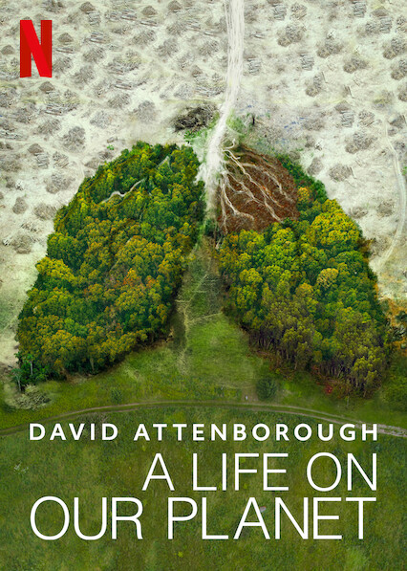Information is interesting and creative (2T)
* Include a short paragraph explaining why you picked the chosen format and how the format adds to the topics (3T)